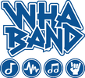
September 9, 2020

Dear 6th Grade Students and Parents:

One of the fun electives offered during the day at WHA is band. Sixth graders are encouraged to participate and no experience is needed! I am excited to teach your child how to play an instrument and be a part of the wonderful experience of making music with their friends. Studies continue to focus on the arts (music) as a vital component in a positive growth of every child. For years we have pointed to the music students as those who have demonstrated a special talent. However, based on extended studies we now know it is the very process of learning music that develops the artistic mind and brings forth the creative potential in all young people. For this reason and many more, becoming a member of the band is strongly encouraged.

The school has a limited number of instruments available for rent, but it is highly encouraged that students acquire their own if possible. During the first week of school, students will have the opportunity to learn about the different instruments, their role in the band, and have the opportunity to “try” out various instruments following the recommended Covid-19 guidelines of sterilization and safety. I have information available on purchasing or leasing an instrument if you are interested. Please do not order an instrument from eBay or Amazon without first contacting your instructor for advice.

Thank you for your interest in the WHA Band program. With your help, together, we will build a strong instrumental foundation for your students. If you have any questions or concerns, please feel free to contact me.

Please check out the WHA Band website: whaband.weebly.com for information about band and the instruments under the 6th grade tab.

Thank you,

Alison Seeger
WHA Bands
547-4228
alisonseeger@whaschools.org
whaband.weebly.com

Parent/Guardian Name:________________________________________________

Student Name: ________________________________________________________

______ Yes, my child will be participating in Elementary Band

______ No, my child will not be participating in Elementary Band

Beginning band instruments include: Flute, Clarinet, Alto Saxophone, Trumpet, Trombone, Baritone and Percussion. There are a limited number of percussion spots available, therefore preference will be given to students who have had a minimum of 1 year of piano and students must audition.

Please choose 3 instruments you are interested in playing:

1st choice ____________________

2nd choice ____________________

3rd choice ____________________

____ I have my OWN instrument

____ I need to purchase/lease my instrument from a music store

____ I need to rent an instrument from the school (The school has a
very limited number of instruments available for rent)

I give my child: __________________________________________ permission to try out different instruments using the Join the Band Instrument Kit. This kit has been designed to meet the Covid -19 Guidelines for sterilization and safety. This kit includes the components to test for aptitude and gauge interest in band instruments. After each individual student use, the components are cleaned with soap and hot water and then sanitized using Sterisol sanitizing spray.

*If your child already has made a decision on what instrument they wish to play, there is no need for your child to try out instruments. Due to Covid-19, I would like to reserve this option for students who have not made a decision. Thank you for your understanding.

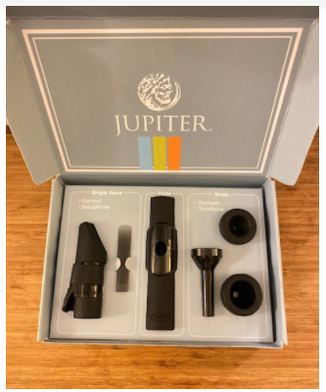

Parent/Guardian Signature: _______________________________________

Date: _______________________________

